|  |  |
| --- | --- |
| ITB logo portrait B&W | INSTITUTE OF TECHNOLOGY BLANCHARDSTOWN  A Taster of Computing  [[VERSION – Unity 2D – C# language]] |

Gravity Guy 2D (2014) - a little computer game...

Part 2 – the story continues …

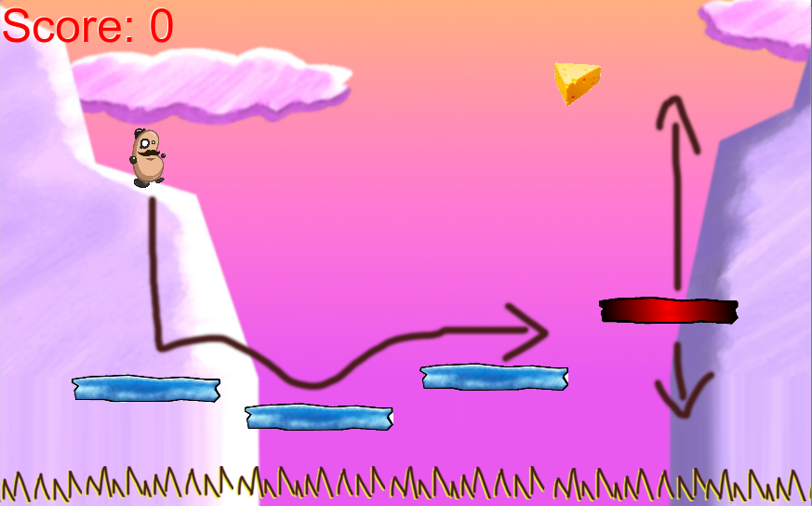

Welcome to “Gravity Guy”. In this multimedia programming exercise you will create a little 2D computer game.

CONTENTS

1 Recap, and aims of this part of the tutorial 3

2 Play a sound when a piece of food is eaten 4

3 Respawn the hero character when it falls down too low … 8

4 Separate the GUI ‘view’ from the Player ‘model’ 9

5 Add killer ‘spike’ objects to the scene 11

6 Add a ‘game over’ scene to our project (for when all lives lost) 14

7 Congratulations … 21

# Recap, and aims of this part of the tutorial

## Features to date

In the first part of this tutorial you implemented the following:

* Hero guy controlled by the user
* Fixed blue platforms
  + Acting as solid ‘Ground’ which can be landed on / jumped from
* Moving red platform
  + Acting as solid ‘Ground’ which can be landed on / jumped from
  + Moving at a customisable speed, between customisable max/min Y values
* A piece of cheese, tagged ‘Food’
  + Which when hit adds to Player’s score
  + And also removes itself from the scene
* An integer score
  + Stored in the player
  + And displayed using a GUILabel

## Skills and knowledge learned

In the first part of this tutorial you learned the following:

* The roles of the different window panels in the Unity editor
  + Project
  + Inspector
  + Hierarchy and Scene
  + Game
* How to:
  + play / stop a game
  + add instances of a prefab into the current scene
  + add a copy of an image sprite to the scene, the copying becoming a gameObject
  + change the properties of a selected gameObject or Project asset
  + add a Box Collider 2D to a gameObject
  + create and add a new string ‘tag’ to a game object
  + activate collision ‘trigger’ event messages for collisions between colliders
  + create a new C# script and add an instance as a component to a gameObject
  + create a prefab, populated with the components and properties of a gameObject in the scene

## New features / skills to be learned in this part of the tutorial

In this part of the tutorial you will add the following features to our game:

* **Play a sound each time we add to the score**
* **Respawn the user when they fall too far down the screen**
* **Separate the score ‘view’ display to the user, from the observed score property inside the Player object**
* **Add killer ‘spike’ gameObjects to the scene**
  + **And have these make the player lose lives and respawn each time they are hit**
  + **This will involve adding a ‘lives’ property to our Player, and adding corresponding GUI display of this property**
* **Add a “Game Over” scene to our game**
  + **And have the user see this scene when they lose their last life**
* *Display scores using GUIText gameObjects, rather than scripted Labels*

# Play a sound when a piece of food is eaten

**The 3 audio object types**

Unity has 3 special sounds related types of objects:

* **AudioClip** – a sound file, such as our ‘yum.mp3’
* **AudioSource** – a component of a game object, allowing a gameObject to play a sound clip file

- this can be empty in a gameObject

or it can be populated with an AudioClip

* **AudioListener** – this is like an electronic ‘ear’ – usually we just work with the default setup, which is that when a new Scene is created in Unity, the Main Camera automatically has an AudioListener

**Other media assets – import them just the same way**

The methods shown in this section can be used to import 2D images, 3D models, audio files, text files, video files, C# scripts etc.

So know you know how to get NEW media/scripting assets into your Unity project …

## Add a sound clip file to a new Project folder “sounds”

Create a folder “sounds” in the Project panel:

* In the Project panel select the Assets folder
* From the ‘Create’ dropdown menu choose ‘Folder’
* Rename the new folder ‘Sounds’

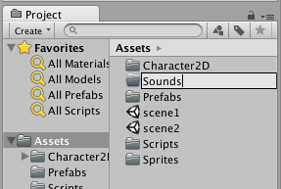

Add a copy of file sounds ‘yum.mp3’ into this new Sounds folder. You can either use the drag-and-drop method, or the Assets| Import menu approach …

* **Drag-and-drop method:**
  + Ensure your **Sounds** folder is selected in the **Project** panel
  + Drag from an OS file window the file into the **Sounds** folder area (right hand side of **Project** panel)
  + You should now see the ‘yum’ sound clip file (with audio wave icon) in the **Project** panel **Sounds** folder

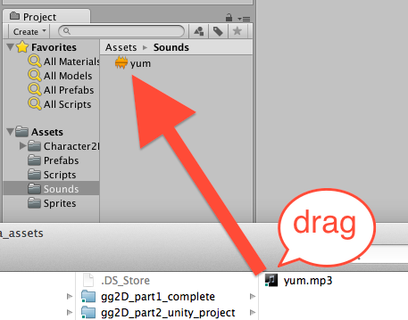

* **Drag-and-drop method:**
  + Ensure your Sounds folder is selected
  + Choose menu: Assets | Import New Asset …

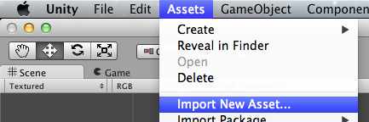

* + Use the file dialog to navigate to and import the sounds file

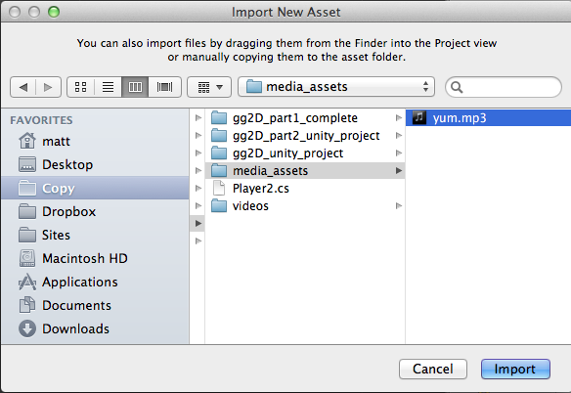

* + You should now see the ‘yum’ sound file (with audio wave icon) in the **Project** panel **Sounds** folder

## Add an AudioSource component, containing our ‘yum’ sound, to the ‘hero’ gameObject

Any Unity gameObject that wants to play a sound must have an ‘AudioSource’ component. The AudioSource component can be pre-loaded with a sound clip file (such as ‘yum’ …), or at run time a particular sound clip file can be loaded into it and then played.

Unity makes things easy – if we drag an AudioClip sound clip file from the Project panel into a gameObject it will automatically add an AudioSource component to the gameObject, and populate it with the sound clip file that was dragged:

* In the **Project** panel select the **Sounds** folder
* In the **Hierarchy** select the **hero** gameObject
* Drag the **yum** audioClip sound file into the Inspector (which should be showing us the components and properties of gameObject **hero)**
* You should now see that the **hero** gameObject contains an **AudioSource** component, and its **AudioClip** property is our **yum** sound clip file

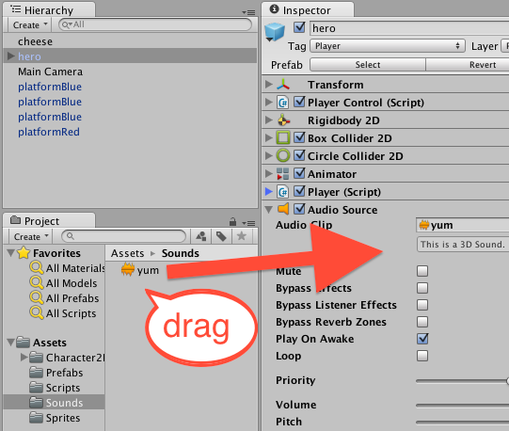

Finally, we do NOT want this sound to play at the beginning of the scene when the **hero** gameObject is instantiated, so we need to DESELET the “Play On Awake” option in the AudioSource component:

* In the **Hierarchy** select the **hero** gameObject
* In the Inspector un-tick the “Play on Awake” property of the AudioSource component

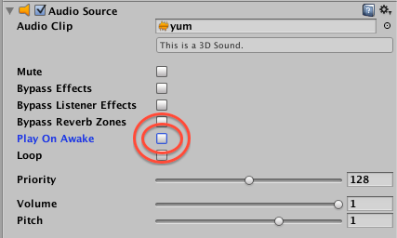

## Add to our Player script class, so that it plays a sound when “Food” items are collided with

Start editing the Player script class in Monodevelop

* In the **Project** panel select the **Scripts** folder
* Double click the **Player** script class file to load it into the **Monodevelop** editor

Recap – your Player script class code should look as follows:

using UnityEngine;  
using System.Collections;  
  
public class Player : MonoBehaviour {    private int score = 0;  
      
    private void OnGUI(){  
        string scoreMessage = "Score = " + score;  
        GUILayout.Label(scoreMessage);  
    }  
  
    private void OnTriggerEnter2D(Collider2D c){  
        string tag = c.tag;  
  
        if('Food' == tag){  
            score++;  
        }  
    }  
}

AFTER the statement where we increment (add 1 to) the score when hitting something with tag “Food”, we are going to add another statement, to tell the gameObject (**hero**) to send a “Play()” message to its AudioSource component (i.e. play the **yum** AudioClip in its AudioSource component). So each time we hit something tagged “Food” we play that sound:

*private void OnTriggerEnter2D(Collider2D c){  
        string tag = c.tag;  
  
        if('Food' == tag){  
            score++;*

            audio.Play();

*}  
    }*

## Playtest your game

You should now hear the **yum** sound when you ‘eat’ a piece of cheese

# Respawn the hero character when it falls down too low …

## Add to our Player script class, to respawn when Y value too low

If our hero player character falls off a platform, it just keeps on falling …

See how – deselect the Game panel option “Maximise on play”, select **hero** in the Hierarchy (so we can see that gameObject’s properties in the Inspector), and run the game. When your character walks off a platform you can see its Y-position keep increasing as a larger and larger negative (downwards) value …

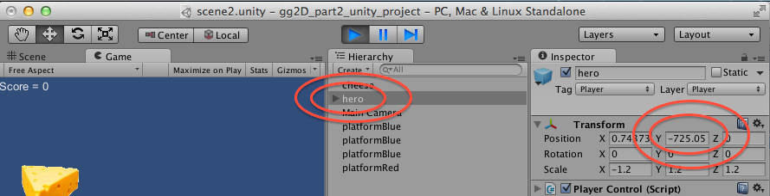

As well as OnGUI(), another message all scene gameObjects are sent EVERY FRAME is the Update() message. So any code in an Update() method will be executed every frame. So we are going to write an Update method that will return our **hero** character gameObject back to its starting postion (0,5,0) if its Y-position is less than -5 (below where all platforms should be).

* In the **Project** panel select the **Scripts** folder
* Double click the **Player** script class file to load it into the **Monodevelop** editor
* Add a new float property **DEATH_Y** set to -5
  + This is the Y-position below which the **hero** character will be moved back to (0,5,0)
* Add a new Update() method to the C# code:

    private int DEATH_Y = -5f;  
  
    private void Update(){  
        float y = transform.position.y;  
  
        if(y < DEATH_Y){  
            Vector3 startPosition = new Vector3(0,5,0);  
            transform.position = startPosition;  
        }  
    }

## Playtest your game

When your **hero** character falls off a platform, after a short time it should reappear back at (0,5,0) – its start position.

**Note – watch our for speed / angle velocity …**

Our current code moves the **hero** back to the start position, but he will still be falling, and moving left/right with the same velocity as he was when off the platform.

A more advanced re-spawning of a character woud also require us to remove any downward speed, or sideways motion, when the character is moved back to its starting position.

But we’ll leave that ‘tweak’ for another tutorial …

# Separate the GUI ‘view’ from the Player ‘model’

## Separate View code from our Player behaviour script class

As a game becomes more complex, it becomes important to ensure each script class has a well defined boundary of responsibility. One example of this is our Player script class – it should maintain and update important properties of our player, such as the player’s SCORE and number of LIVES left, and any INVENTORY the player may be carrying.

However, the Player script class should NOT worry about HOW the values of these properties are COMMUNICATED to the user.

Each important property should be a PRIVATE variable, but should offer PUBLIC accessor methods (getters and setters) for any other objects that have responsibilities that require them to access these properties of the Player.

We are now going to REFACTOR our code, to separate the VIEW of player properties (our GIU to the user) from the Player script class itself.

## Remove GUI code from Player, but add public GET method for ‘score’

Let’s remove the GUI code from our Player script class, but add a public GETTER method for the important ‘score’ property:

* In the **Project** panel select the **Scripts** folder
* Double click the **Player** script class file to load it into the **Monodevelop** editor
* Edit the code as follows:
  + Remove method OnGUI()
  + Add a new method GetScore()

*using UnityEngine;  
using System.Collections;  
  
public class Player : MonoBehaviour {  
    private int score = 0;***public int GetScore(){  
        return score;  
    }***private float DEATH_Y = -5f;  
  
    private void Update(){  
        float y = transform.position.y;  
  
        if(y < DEATH_Y){  
            Vector3 startPosition = new Vector3(0,5,0);  
            transform.position = startPosition;  
        }  
    }  
  
    private void OnTriggerEnter2D(Collider2D c){  
        string tag = c.tag;  
  
        if("Food" == tag){  
            score++;  
            audio.Play();  
        }  
    }  
}*

## Create new GameGUI script class, and add it to the Main Camera

Create a new C# script named GameGUI:

* In the **Project** panel select the **Scripts** folder
* From the **Project** ‘Create’ menu choose ‘C# Script’ and rename this new script “GameGUI”
* Double click your new **GameGUI** script class file, and in MonoDevelop edit its code to be the following:

**using UnityEngine;  
using System.Collections;  
  
public class GameGUI : MonoBehaviour {  
    public Player player;  
  
    private void OnGUI(){  
        int playerScore = player.GetScore();  
        string scoreMessage = "Score = " + playerScore;  
        GUILayout.Label(scoreMessage);  
    }  
}**

## Add an instance of our GameGUI script class as a component of Main Camera

A script class does nothing, unless an instance of it has been added as a component of a gameObject in the scene. Do the following:

* In the **Project** panel select the **Scripts** folder
* In the Hierarchy select the **Main Camera** gameObject
* Drag the C# script class file from the **Project Scripts** folder into the **Inspector**
* You should now see that Hiearchy gameObject **Main Camera** now has a component Game GUI (Script)

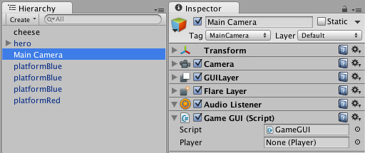

We now need to make a link between the **hero** gameObject in our Hierarchy, and the ‘player’ variable in our GameGUI component in the **Main Camera**. Do the following:

* In the Hierarchy select the **Main Camera** gameObject
* Drag the **hero** gameObject from the Hierarchy into the Player property of the Game GUI (Script) component of the **Main Camera**
* The public ‘Player’ variable of the GameGUI script component of Main Camera should now indicate that it is a reference (link) to **hero (Player)**
  + The instance of the Player script class that is a component inside the **hero** gameObject

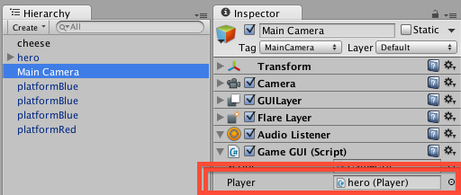

The game will look just the same to the user – but you know that the GUI ‘view’ has now been separated from the Player ‘model’ of player’s properties.

# Add killer ‘spike’ objects to the scene

## Add a new property ‘lives’ to our Player script class

Let’s start the player off with 3 lives. We need to add a property ‘lives’ to our Player script class, and also add a public ‘getter’, to allow our GameGUI to retrieve and display the value of the ‘lives’ variable:

Add a ‘lives’ inteter property to script class Player, and a corresponding public ‘getter’:

* In the **Project** panel select the **Scripts** folder
* Double click the **Player** script class file to load it into the **Monodevelop** editor
* Edit the code as follows:
  + Add a new private integer property ‘lives’ initialised to 3
  + Add a new public method GetLives()

*using UnityEngine;  
using System.Collections;  
  
public class Player : MonoBehaviour {  
    private int score = 0;***private int lives = 3;***public int GetScore(){  
        return score;  
    }***public int GetLives(){  
        return lives;  
    }**

## Edit our GameGUI to display the lives property to the user

Add code to our GameGUI script class to display the player’s lives integer on screen:

Add a ‘lives’ integer property to script class Player, and a corresponding public ‘getter’:

* In the **Project** panel select the **Scripts** folder
* Double click the **Player** script class file to load it into the **Monodevelop** editor
* Edit the code as follows:
  + We will move the Score display code into new method DisplayScore()
  + We will create a new Lives display code method DisplayLives()

*using UnityEngine;  
using System.Collections;  
  
public class GameGUI : MonoBehaviour {  
    public Player player;***private void OnGUI(){  
        DisplayScore();  
        DisplayLives();  
    }  
      
    private void DisplayScore(){  
        int playerScore = player.GetScore();  
        string scoreMessage = "Score = " + playerScore;  
        GUILayout.Label(scoreMessage);  
    }  
      
    private void DisplayLives(){  
        int playerLives = player.GetLives();  
        string livesMessage = "Score = " + playerLives;  
        GUILayout.Label(livesMessage);  
    }  
}**

## Add some copies of the ‘spikes’ prefab as gameObjects to the scene

Rather than our player falling into some invisible minimum Y position, let’s actually display some ‘spikes’, whereby the player loses a life when they fall onto them.

Add some copies of the ‘spikes’ prefab as gameObjects to our scene, in a row BELOW the platforms:

* In the **Project** panel select the **Prefabs** folder
* Drag copies of the **spikes** prefab onto the scene, in a row below the platforms:

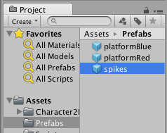

Your scene should now look something like the following:

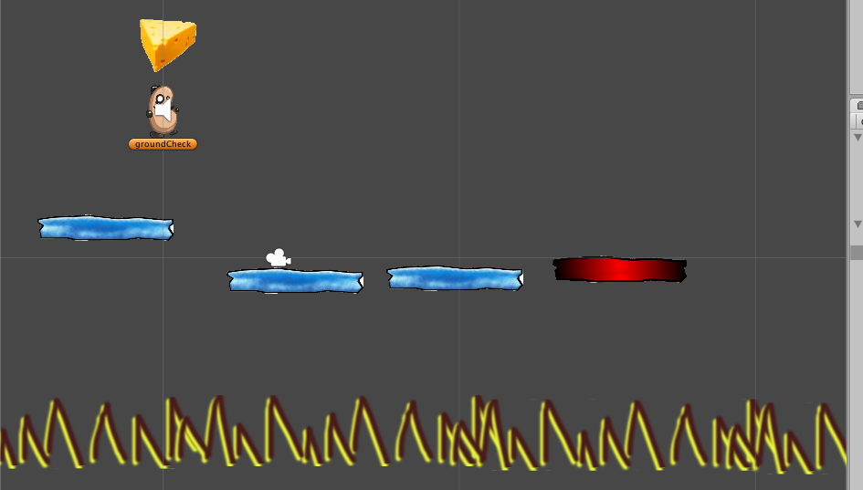

­­­ ­­

If you select a ‘spikes’ gameObject, you’ll see that they have their collider ‘trigger’ ticked, and have the tag ‘Spikes’:

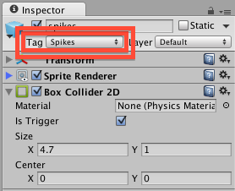

## Edit Player code, to decrement lives when hit something tagged ‘spikes’

We now need to edit our Player script class, so that when it collides with something tagged ‘spikes’, we decrement the lives, and move it back to the start position.

NOTE – we’ll also remove the code that repositions the character if the Y value is too low … so the onus is on the LEVEL DESIGNER to ensure all falls lead to ‘spikes’ …

Let’s edit our collision trigger method, and turn the code to move the object to the start position into a separate method:

* In the **Project** panel select the **Scripts** folder
* Double click the **Player** script class file to load it into the **Monodevelop** editor
* Edit the **code as follows:**

*using UnityEngine;  
using System.Collections;  
  
public class Player : MonoBehaviour {  
    private int score = 0;  
    private int lives = 3;  
      
    public int GetScore(){  
        return score;  
    }  
      
    public int GetLives(){  
        return lives;  
    }  
  
    private float DEATH_Y = -5f;  
  
    private void OnTriggerEnter2D(Collider2D c){  
        string tag = c.tag;  
  
        if("Food" == tag){  
            score++;  
            audio.Play();  
        }* **if("Spikes" == tag){  
            lives--;  
            MoveToStartPosition();  
        }  
    }  
  
    private void MoveToStartPosition(){  
        Vector3 startPosition = new Vector3(0,5,0);  
        transform.position = startPosition;  
    }***}*

# Add a ‘game over’ scene to our project (for when all lives lost)

## Create a new blank scene, and name it “gameOver”

Interactive Multimedia games and applications tend to break up naturally into different screens, or levels, or ‘scenes’ as they are know in Unity:

* Welcome to the game
* Main Menu
* High Scores
* Credits
* Instructions
* Level 1 playing
* Level 1 complete (with button to start level 2)
* Leve 1 lost / Game Over
* Level 2 playing etc.

FIRST – save your work on **scene1** that you have been adding to up to know.

Create a new scene:

* Choose menu: **File | New Scene**
* Your should now see that all game objects in the Scene and Hiearchy panels have gone
  + Except for the default **Main Camera** that is always added to a new scene
* You can also see that the NAME of the scene you are now working on (in the Unity application window title bar) has changed from “scene1” to “untitled”

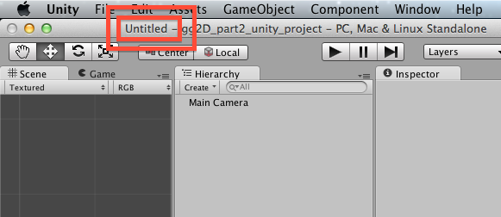

* Now SAVE and NAME your new scene
  + Choose menu: **File | Save Scene As …**
    - Save the scene in the project “Assets” folder
    - Call it “**gameOver”**

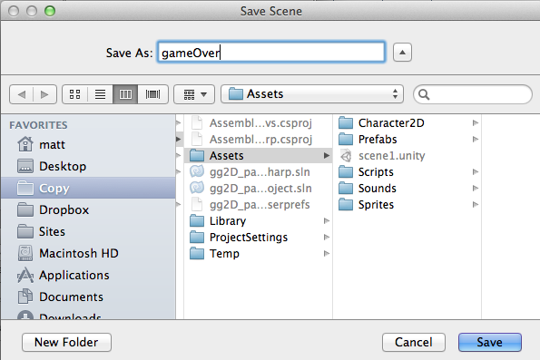

You should now see that you are editing scene **gameOver:**

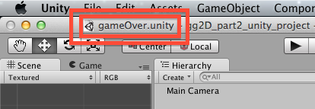

## Use GUIText to display the message “GAME OVER”

Add a big text message to the user using GUIText gameObjects:

* From the “Create” menu of the **Hierarchy**, choose GUIText

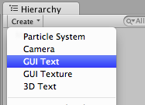

* You should now see a new GUIText gameObject in the **Hierarchy:**
  + **NOTE:** you can’t see the contents of a GUIText in the **Scene** panel, so click the **Game** panel, and you’ll see the preview of GUIText there with a blue background
  + **OR** just run your game scene – you’ll see just the text, since there is nothing else in our scene except for the camera …

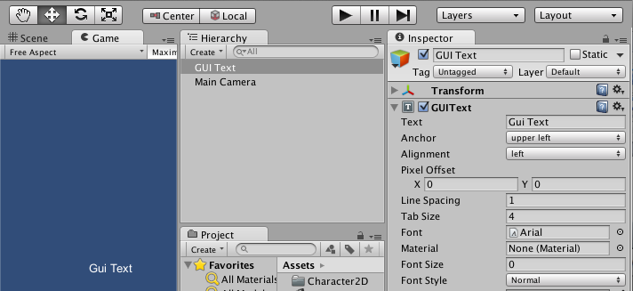

* with the new **GUIText** gameObject selected in the **Hierarchy**
  + in the **Inspector** change its GUIText Text property to read “GAME OVER”

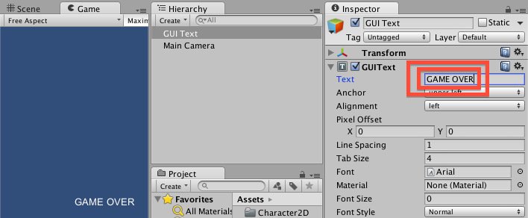

* with the new **GUIText** gameObject selected in the **Hierarchy**
  + in the **Inspector** change its GUIText properties as follows:
    - set Anchor to “middle center”
    - set Alignment to “center”
    - increase Font Size to 47
      * TIP: move mouse over the words Font Size and click and drag to the right to increase the number …
  + this shoud result in your GAME OVER message appearing as big text in the center of the **Game** panel

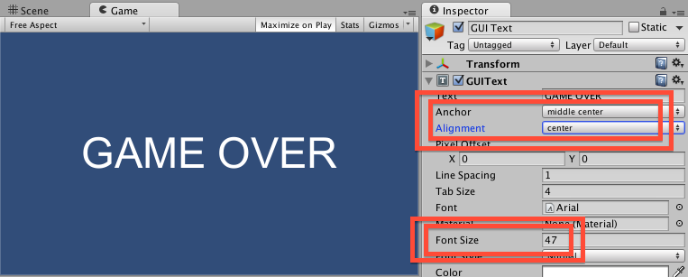

## Edit Player code, to load scene “gameOver” when lives less than zero

We now need to edit our Player script class, so that when the last life is lost (lives < 0) we make Unity change to our game over scene.

Let’s save our gameOver scene, go back to scene1, and then edit the Player script class …

* Save your **gameOver** scene
* Reload **scene1**
  + Double click **scene1 i**n the Assets folder of the **Project** panel
* Double click the **Player** script class file to load it into the **Monodevelop** editor

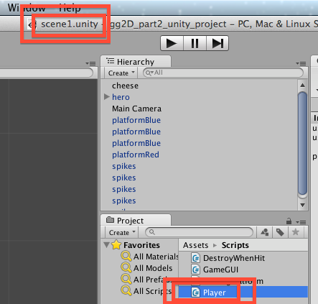

* Edit the **code as follows,** so that we tell the Unity **Application** to load the “**gameOver”** scene when lives are all lost:

*using UnityEngine;  
using System.Collections;  
  
public class Player : MonoBehaviour {  
    //  
    // public getters  
    //  
    public int GetScore(){  
        return score;  
    }  
      
    public int GetLives(){  
        return lives;  
    }  
  
    //  
    // properties  
    //   
    private int score = 0;  
    private int lives = 3;          
    private float DEATH_Y = -5f;  
  
    //  
    // methods  
    //***private void Update(){  
        if(lives < 0){  
            Application.LoadLevel("gameOver");  
        }  
    }** *private void OnTriggerEnter2D(Collider2D c){  
        string tag = c.tag;  
  
        if("Food" == tag){  
            score++;  
            audio.Play();  
        }  
  
        if("Spikes" == tag){  
            lives--;  
            MoveToStartPosition();  
        }  
    }  
  
    private void MoveToStartPosition(){  
        Vector3 startPosition = new Vector3(0,5,0);  
        transform.position = startPosition;  
    }  
      
}*

## Playtest your game

Starting with the editor in **scene1**, run your game. Then keep falling off platforms to make the number of lives less than zero …. What happens?

The game did NOT load our **gameOver** level ?? Why not ?? And what is that error message:

Level 'gameOver' (-1) couldn't be loaded because it has not been added to the build settings.

To add a level to the build settings use the menu File->Build Settings...

UnityEngine.Application:LoadLevel(String)

Player:Update() (at Assets/Scripts/Player.cs:28)

This is what has happened …

* Unity will only let you load a scene if the scene you are trying to load is included in the list of scenes that will be packaged up into the final ‘built’ application (whether a stand along desktop application, or web player game, or mobile phone app, or console game etc..)
* Sometimes you will create scenes just to TEST things out
  + You’ll never include these in your final build
* Unity does not want you to be able to write in code the loading of a scene that will cause an error when the final application is built for deployment or selling etc.

The SOLUTION …. You must now start telling Unity which scenes to include in your build.

## Add ‘scene1’ and ‘gameOver’ scenes to your build list

Let’s add ‘scene1’ to the build:

* When editing **scene1** choose menu: File | Build Settings …

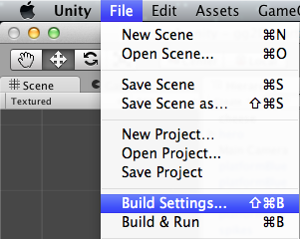

* Delete any scenes that might be listed already, then click the button “Add Current”:

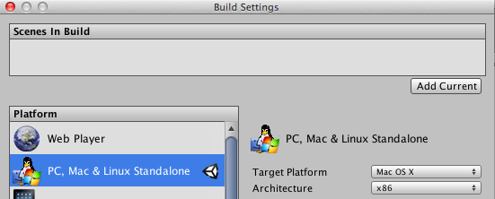

* You should now see **scene1** added to the list of Scenes in Build:

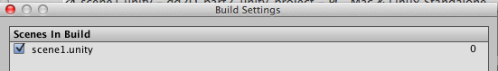

* Now load scene **gameOver**
  + You can either close the Build Setting dialog window, and re-open it after loading **gameOver**, or just move this window to one site
* With scene **gameOver** loaded, go back to the Build Settings diaglog, and click “Add Current” again
  + You should now see **scene1** and **gameOver** listed as scenes in the build
  + (note the scene list also have corresponding numbers, starting at 0 – Application.LoadLevel() also accepts the integer ‘index’ of the scene to load, as an alternative to the text name of the scene file …)

## Playtest your game

Close the Build Settings, and reload **scene1**, then run your game. Then keep falling off platforms to make the number of lives less than zero

You should now see the GAME OVER message once your lives gets below zero ☺

# Congratulations …



**Congratulations**

**You have now created part 2 of the tutorial !**